GTB  
  
**QA**  
[DEV 21.15] OT-1234 | XT | ES | BP | 3.0 Popin - NGC BPA (BPC)

**Jira ticket:**  
<https://jira.uhub.biz/browse/GTBEMEAOPT-1234>

**Site**  
<https://www.ford.es/>

**Test location**  
See Popin Location

**Impression ID:**

tt:nwp:opt-1234:xt:ase:ngc-bpa-bpc

**Test Description**

There are 2 parts to this ticket:

1. Collecting the Data
2. Displaying the popup

It must happen in that order.

NOTE: This ticket only works for vehicles using the new Build and Price configuration (see image below), no data will be recorded if the old configurator is used.

**Collecting the Data:** View the QA Link, in the top right corner select “Configurador”. To configure a vehicle simply click on it, once loaded, you should now be in the Build and Price section, you can also leave now to trigger a popup. Some popup locations will only appear if you selected a specific model though, so if that is the idea, please select a model before leaving the page in order to get a popup to appear.

**Displaying the Popup:** The popup can display in multiple locations if certain conditions are met.

* Homepage
* NPP of relevant vehicle (eg Fiesta popin to only appear on Fiesta NPP)
* Model Pages of relevant vehicle
* Appear in PV promotions only if it is a personal vehicle
* If vehicle is present in Mini Showroom -> SUV & Crossover, then show also on SUV page (see footer on Homepage for link)
* If vehicle is present in Mini Showroom -> Family Cars, then show also on Family Cars page (see footer on Homepage for link)
* If vehicle is present in Mini Showroom -> Performance, then show also on Performance page (see footer on Homepage for link)
* If vehicle is ST-line, then show also on ST-line page (see footer on Homepage for link)
* If vehicle is Vignale, then show also on Vignale page (see footer on Homepage for link)
* If vehicle is Tourneo Courier, Tourneo Connect, S-Max, Galaxy or Tourneo Custom and Transit Bus, then show also on People Carrier page (see footer on Homepage for link)

The popup can only appear a maximum of 3 times, with a 15 minute duration in between popups. Popups appear after 15 seconds of landing on the page. The CTA on the popup will return the user to the point where he dropped off, or the next step based on whether a selection was required on the page you dropped off on.

For example, if you just entered the build and price and left. You’d return to that exact page as you need to make a choice between which model you want. Whereas if you were on the colour page, the colour is pre-selected once it loads so you would go to the next step which is Interior ( I think ).

So in short, if the page you’re on contains only 1 button for you to proceed to the next step, usually found in the bottom right corner, then leaving this page will take you to the next page, however if you’re on a page where there are multiple options similar to the Model Selection screen, you will return to this page.

The Popup:  
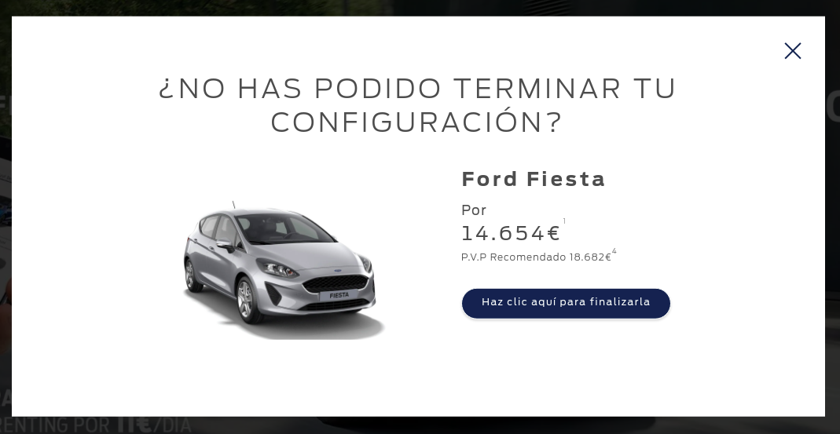

Content of the Popin:

Heading: ¿NO HAS PODIDO TERMINAR TU CONFIGURACIÓN?

CTA: Haz clic aquí para finalizarla

Price Information: (ignore the actual values below, just an example)

Por

14.550€1

P.V.P Recomendado  
€19.5554

**Dynamic Disclaimers on 1 and 4:**

To verify that the content of the disclaimers are correct. During the Configurator Journey, the prices should appear in the top right corner, with symbols to view their disclaimers. NOTE: The symbols might not match. You’ll have to match the price/text to the popin to see which is which, but in general, the one that’s on the left is the Offer Price and the one on the Right is the Retail price.

On the popup, the top one is the Offer Price and the 2nd is the retail price. However, if only one price appears, that price being displayed is most likely the retail price, not the offer price.

**Browser:**   
All  
  
**Device:**   
All  
  
**Audience rules:**   
All traffic

**QA Links:**

<https://www.ford.es?at_preview_token=Trt1hktclfgHS7-JsHVxVg&at_preview_index=1_1&at_preview_listed_activities_only=true>